Measurement Outline: Magnon Angular Momentum

Sample: Ferromagnetic insulator with magnetization (M) = the saturation magnetization (Msat). Note M and Msat denote the total magnetization (proportional to volume). The sample temperature (T) is set such that Td << T < Tc, where Td represents the Debye temperature, and Tc represents the Curie temperature. This temperature would cause any phonon angular momentum to be negligible.

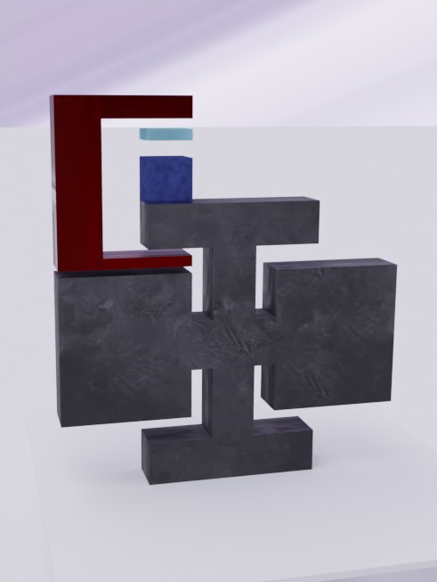Setup:

oscillator

sample

magnetometer (Hall effect sensor)

AC magnet (H + Asin(wt) upward)

Alternate

The microwave head is designed as in [1]. The dc electromagnet field H has an intensity of ~1 T, enough to saturate the sample.

Procedure:

* Let
  + Jtot = total angular momentum,
  + Jlat = lattice angular momentum,
  + Jspin = spin angular momentum
  + Jorb = orbital angular momentum,
  + Jph = phonon angular momentum,
  + Jm = total magnon angular momentum.
* Measurement 1:
  + $J_{tot} = J_{lat} + J_{spin} + J_{orb} + J_{ph} + J_{m}$, where Jm = 0 since sample is at saturation magnetization.
* Measurement 2:
  + Excite magnon production via microwave head.
  + After head has been turned off, measure M via magnetometer and measure A (oscillator amplitude) via interferometer.
* Analysis

For n magnons produced via microwave head,

M = Msat – n γ ћ, for γ = $\frac{g_{e} e}{2 m_{e}}$, where $g_{e}$ is the g-factor for an electron $\sim$ 2, and $m_{e}$ is the electron mass.

Solving for n: n = $\frac{M_{sat} - M}{γћ}$.

Angular momentum:

$J_{tot} = J_{lat}^{2} + J_{spin}^{2} + J_{orb}^{2} + J_{ph}^{2} + J_{m}^{2}$.

Note $\left(J_{spin}^{2} + J_{orb}^{2}\right)-\left(J_{spin} + J_{orb}\right)=-nћ$.

So $J_{m}^{2} =nћ-\left( J_{lat}^{2}- J_{lat}\right)-\left(J_{ph}^{2}-J_{ph}\right)$ and since Td << T, $\left(J_{ph}^{2}-J_{ph}\right) \sim 0$.

∴ $J_{m}^{2} =nћ-\left(∆J_{lat}\right)$, where $∆J_{lat} = \left( J_{lat}^{2}- J_{lat}\right)$.

⇀ $J_{m_{0}} =ћ-\left(\frac{∆J_{lat}}{n}\right)$, where $J_{m_{0}}$ denotes the angular momentum of a magnon.

Via basic underdamped oscillator theory (given large Q),

$ϴ_{A}=\frac{∆J_{lat}}{\sqrt{IK}}$,

where $ϴ_{A}$ denotes oscillator angular amplitude, I denotes the inertia of the oscillator-mass system, and K denotes the torsional constant of the oscillator.

∴ $J_{m_{0}} =ћ-\left(\frac{ϴ_{A}\sqrt{IK}}{n}\right)$.

Null Hypothesis:

$J_{m_{0}}=0$ ⇀ $ϴ_{A}=\frac{nћ}{\sqrt{IK}}$ Note $I = I_{0}+I_{s}$.

From [2], the Series B oscillators have f = 9000 Hz, and K = 0.39 Nm.

⇀ $I_{0}=1.21⋅{10}^{-10} Kg⋅m^{2}$

The head radius (R) is 4mm, so the head amplitude

$A_{h}=\left(4⋅{10}^{-3}\right)⋅ϴ_{A}=\left(4⋅{10}^{-3}\right)⋅\frac{nћ}{\sqrt{IK}} m$

Possible materials:

The Ah have been calculated below for 1 $mm^{3}$ samples taken as points located on the edge of the oscillator head. Note that as:

$I\sim I_{0}$,

$A_{h}=\sqrt{ρ_{m} V}\frac{ρ_{e}}{ρ_{m}}\frac{λ ћ}{R \sqrt{K}} m$,

where $ρ_{m}$ is mass density, $ρ_{e}$ is electron density, V is volume, and $λ$ is the proportion of electrons which have had spin reversed ($\frac{n of magnons}{n of electrons}$). So higher density materials with higher electron to mass density are preferable.

|  |  |  |  |  |  |  |
| --- | --- | --- | --- | --- | --- | --- |
| Material | Tc | Td | Ρ | Ah if $J_{m_{0}}=0$ (Series B osc.) | Ax (exchange F)  (microwaves) | Notes |
| CrO2 | 386 K | - |  | 2 pm |  |  |
| YIG(Y3Fe5O12) | 560 K | - |  | 42.6 pm | $$0.4⋅{10}^{-11}\frac{J}{m}$$ | Technically ferrimagnetic. |
| Ba2NaOsO6 | 6.8(3) K | - |  | 43.9 pm |  |  |

Note that as $A_{h}$ is proportional to $\sqrt{V}$, a 1 $cm^{3}$ instead of 1 $mm^{3}$ sample has a 32x increase in $A_{h}$. So for example, a 1 $cm^{3}$ YIG would have $A_h = 1347 pm = 1.3 nm$, which is much more conducive to measurement. A possible upscale of the oscillator system may be required.

An alternative set of measurements below and above the Tc ought to have the same scale, so an upscale may still be required.